Department of Computer Science
Project Proposal Summer 2024-2025
Course Title | Web Technologies | Section | R | #Group | 17
Group Member
Serial | Student ID | Name | Signature
1. | 23-51087-1 | Grontho Chandra Roy | Grontho
2. | 23-51934-2 | Sadia Islam | Sadia
Project Title:
Online Bookstore Management System
Short Description:
Type of user: 1. Guest User 2. Registered User / Customer 3. Admin
Common Features (Available to All Users)
- Authentication
- Login to the system
- Logout from the system
- User registration
- Account Management
- Change or reset password
- Manage profile information (view, edit, delete)
- Dashboard
- Access a personalized dashboard after login
Specific Features by User Type
- Features of Guest User
- Search Book & View Book Details page
- Contact Support
- Add Books to Wishlist
- View Latest Arrivals
- View Book Ratings

- Features of Registered User
- Add to Cart & Remove from Cart
- Update Quantity
- Place Order & Cancel Order
- View Order History
- Choose Payment Option

- Features of Admin
- View Registered Users
- Assign a Discount to Books
- View Customer Orders
- Check Low Stock Alert (Add / Delete item)
- Generate Sales Report
- Category Management

N.B:
Each user type must have at least 5 distinct features different from the others. Additional features may be added if desired.
Each Group Need to submit the Use Case Diagram, Class Diagram and Activity Diagram of their project.
Group Member should be 2.

Activity Diagram
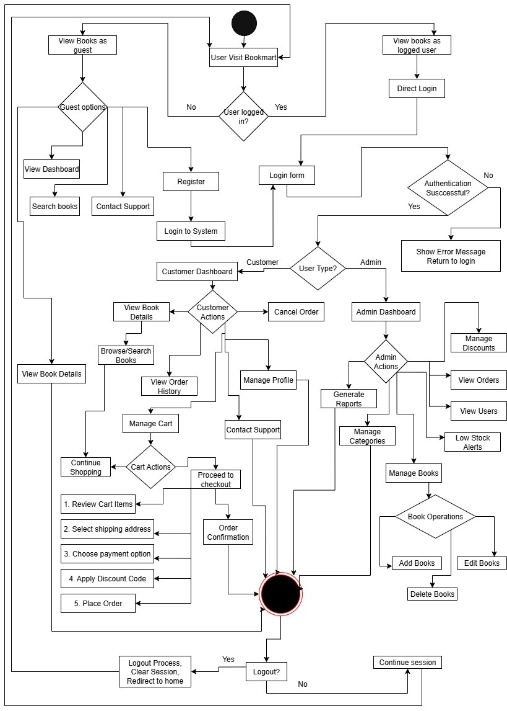
Class Diagram
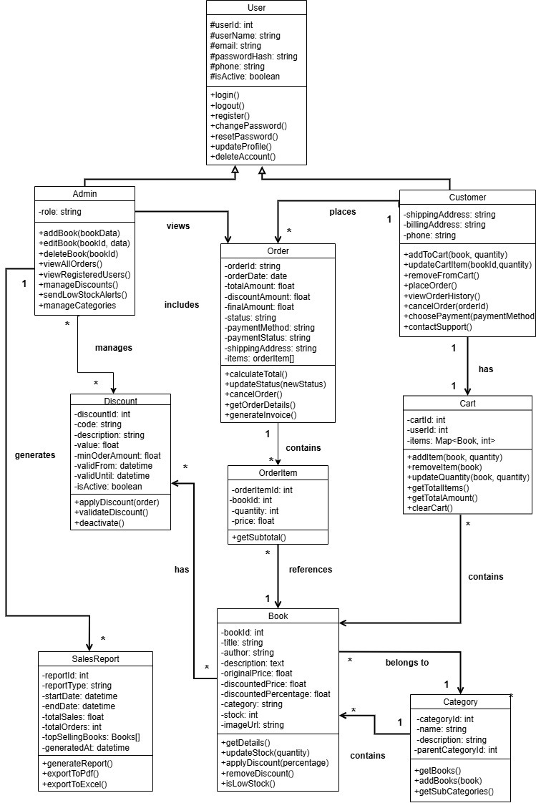

Use Case Diagram
